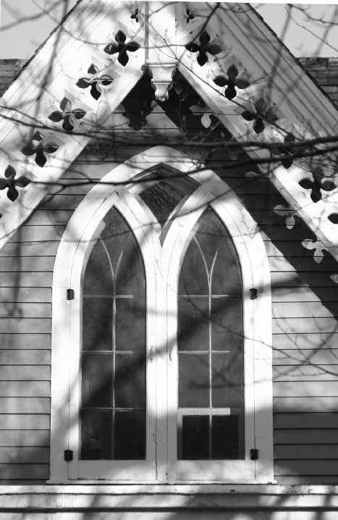

CPC Welcomes Our Newest Members

Richard & Martha Olson - their Children: David, Elizabeth, Peter, Catherine, Daniel

Bryan & Tess Bademan - their Children: Elsa, Mary

Mark & Katie Genua – their Children: Rebekah, Rachel, Marc

Hillary Selle
James Thomas, III
Christopher (C.J.) Dickson

Dan Grimm

